The 3rd Annual Pumpkin Carving Festival to

Carve for a Cause
Funding Request
Application

Benefit
Return application to:
PO Box 1204
New Paltz, New York 12561
Contact: Marianne Murray
(C) 914-262-2391
www.carveforacause.com

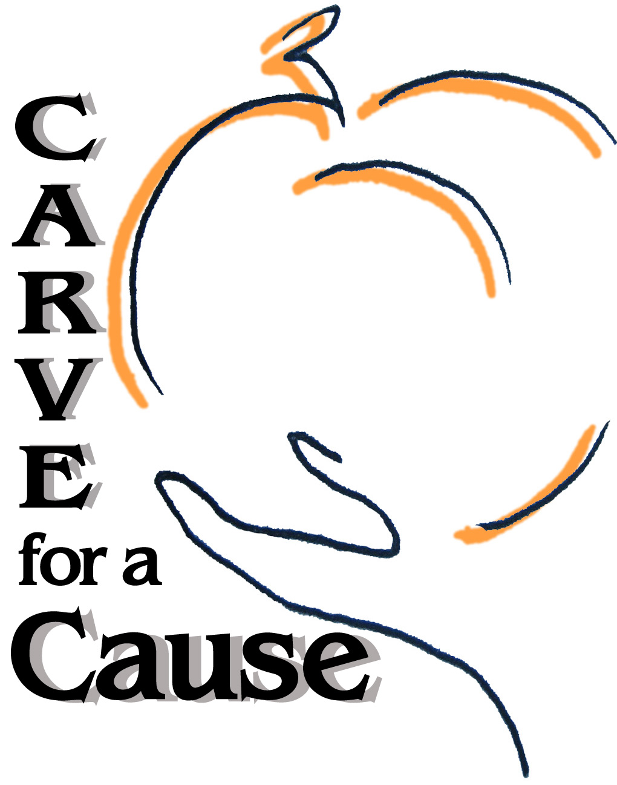
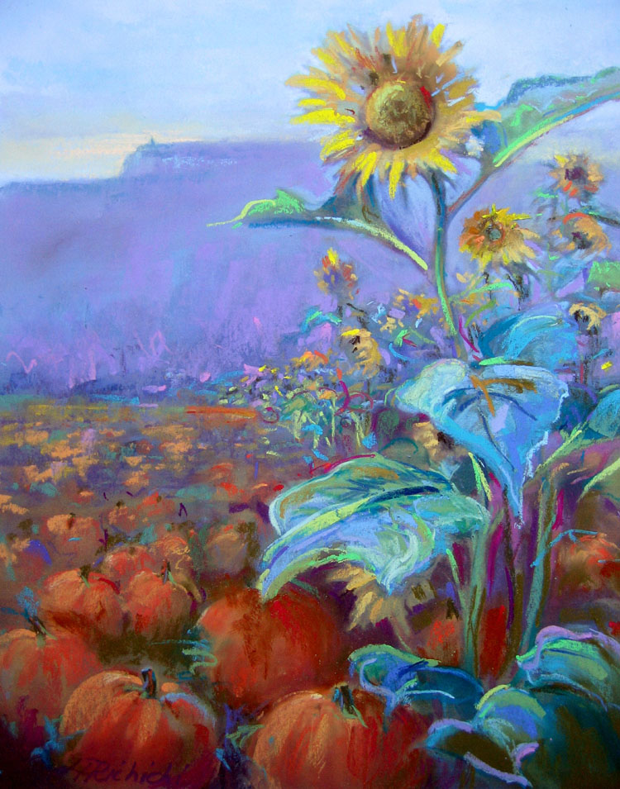
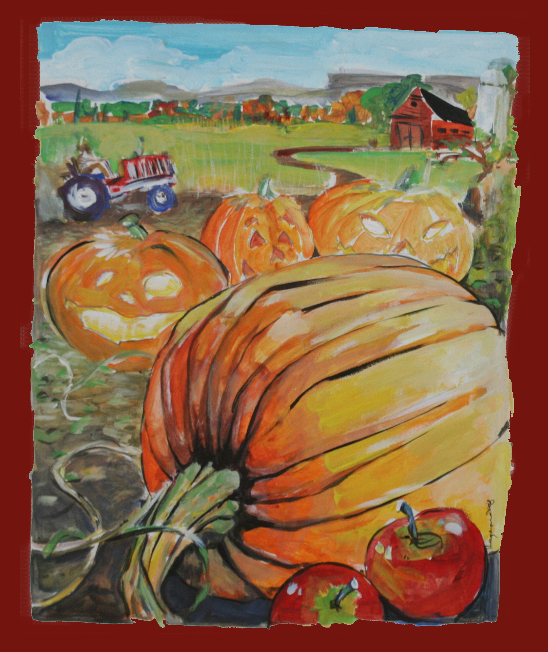

CREW MEMBERS

Marianne Murray

Cathy Sifre

Erika Eisenberg

Lauren Ludwig

Nicole Lee

Lisa Ferrante

Marlene Wood

Carve for a Cause is a grass roots organization created to raise funding and awareness for non-profits that strive to fulfill the basic unmet needs of families and children living in Ulster County. To be considered as a potential recipient for this year’s event, we ask that you answer the following questions:

Organization Name:_____________________________________________

Address:______________________________________________________

Phone/Email:__________________________________________________

Contact Person:________________________________________________

Briefly describe your organization’s mission, date founded and annual budget_______________________________________________________

_____________________________________________________________

_____________________________________________________________

How many persons does your organization serve?___________

Describe a short and/or long-term project or program you would be able to fulfill with the money received from Carve for a Cause________________________________________________________

_____________________________________________________________

_____________________________________________________________

What is the target population of this project or program?_____________________________________________________

What is the timeline for completion or implementation of the project or program being proposed?________________________________________

How will the fulfillment of this request enhance the quality of life of those you serve and the surrounding community?_____________________________________________________________________________________________________________________________________________________________________________

_____________________________________________________________
Signature and Title Date

